**Overview**

This project is started with the goal to find ways to increase revenues to offset the new operating costs at Big Mountain Resort in Montana. The estimate of the premium over the current ticket price should make sense for visitors when compared to resorts in the same category. In order to bring the new revenue, ticket price for an adult on weekend (referred as AdultWeekend) seemed like a viable option. Though the weekday price is also a possibility, AdultWeekend is considered. Out of the two modelling techniques that were attempted, namely, linear regression and Random Forest Regression, it was found that the Random forest regression had a smaller error. The predicted price change of $14 from the current value of $81 bears an error of $9.5. The following sections provide brief descriptions the process.

**Data Exploration**

With the given data on various resorts across the country, and an additional information on population and area for each state in USA was added. The initial dataset had 330 rows and 27 columns and a cleaning, augmenting and adding few new features, the final dataset had 277 rows and 32 columns.

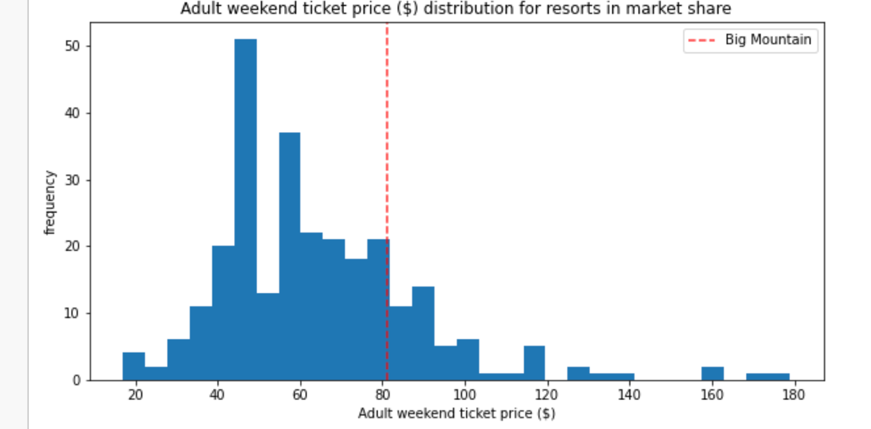Fig. 1

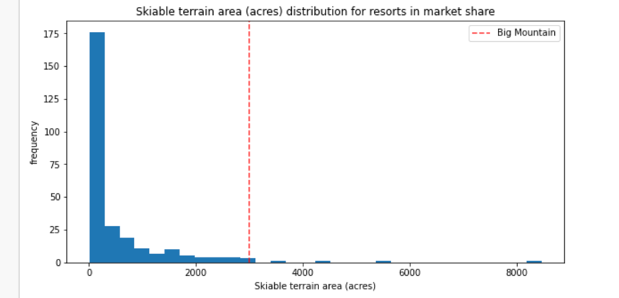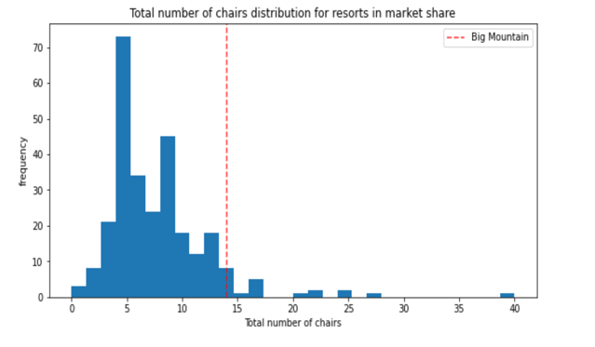

Fig. 2 Fig. 3

It can be inferred from Fig. 1, that the AdultWeekend ticket price for Big Mountain Resort is more than most parks across the states (about 30 states). However, Fig. 2 and 3 show that skiable area and total chairs are large for Big Mountain. In order to support any increase in the ticket price, such features will provide support.

**Modelling**

Out of the many possible features, after eliminating the closely correlated features and choosing the top 4 features that contribute the most, a random forest regression model is developed. the model is trained and tested and the predicted AdultWeekend ticket price was $95, The mean absolute error was $9.5. If each adult visitor buys 5 tickets, the revenues will be about $347,4638. That means the increase in price is about $14 and there is an error of $9.50. Considering the error, a price increase of $5 will make the AdultWeekend will make it above average. Several scenarios can be considered by changing other features.

From the two modelling scenarios that used -1. closing one run and 2. increasing the vertical drop

of 150 ft , and the results are shown below in Fig. 4, it can be inferred that the ticket price will not change if 1 run is closed. The ticket price needs a decrease of $.1,25 by closing upto 6 runs.

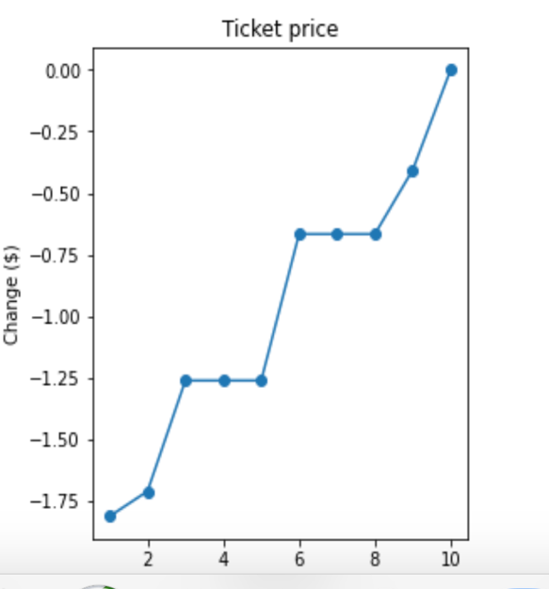Fig. 4

It means 𝑡ℎ𝑎𝑡 𝑎𝑙𝑜𝑛𝑔 𝑤𝑖𝑡ℎ 𝑡ℎ𝑒 𝑒𝑟𝑟𝑜𝑟, 𝑝𝑟𝑖𝑐𝑒 𝑖𝑛𝑐𝑟𝑒𝑎𝑠𝑒 𝑜𝑓 1.99 of the price increase will be received with no change in revenue by closing one run. It means that by closing one run, the ticket price be increased further by $1.99 along with saving operating costs for that one run and also bringing better value of the large skiable area and many chairs at Big Mountain Resort.

**Conclusions**

Adult weekend price is modeled here an d price increase of $7 is recommended and closing one run. However, increasing the ticket price too much can have adverse effects. Hence, modelling weekday ticket price can be modified along with considering other operating-cost-saving scenarios can be modelled and the solution can be further improved.